I
n this session we will try to understand what is decision table HIT policy ? and how it works?

Each row in a decision table is a rule. The columns represent inputs and, at the end, one (or occasionally more than one) output. Each input cell in a rule represents a true/false condition for the input: Does it match a particular value, fall into a specified range, etc.? (A hyphen in the cell means the input is irrelevant in this rule; the cell value is true by default.) If all input cells for the rule evaluate to true, the rule is said to match, and the output cell value is selected as the decision table output.

Camunda DMN Decision Table HIT policies
Hit policy comes into play when more than one rule matches. In that case the rules are said to overlap, but that’s not necessarily an error. Sometimes it’s easier to create decision tables with rule overlap, and those tables rely on the hit policy to select the proper output value. Hit policies that select a single output value, plus a few more that create a list of output values.
Camunda DMN HIT Policies
- Single HIT
- FIRST
- ANY
- UNIQUE
- PRIORITY

- Multiple HIT
- RULE ORDER
- OUTPUT ORDER
- COLLECT

FIRST: multiple (overlapping) rules can match, with different output entries. The first hit by rule order is returned (and evaluation can halt).

UNIQUE: no overlap is possible and all rules are disjoint. Only a single rule can be matched.

ANY: there may be overlap, but all of the matching rules show equal output entries for each output, so any match can be used. If the output entries are non-equal, the hit policy is incorrect and the result will be empty and marked as failed. When strict mode is disabled the last valid rule be the result. (The violation will be present as a validation message)

PRIORITY: multiple rules can match, with different output entries. This policy returns the matching rule with the highest output priority. Output priorities are specified in the ordered list of output values, in decreasing order of priority. When strict mode is disabled and there are no output values defined the first valid rule be the result. (The violation will be present as a validation message)

HIT policy FIRST

We will use below workflow diagram to demonstrate decision table task to execute DMN rules.

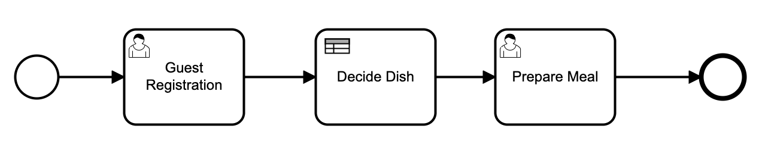
1. Process: Process HIT Policy First

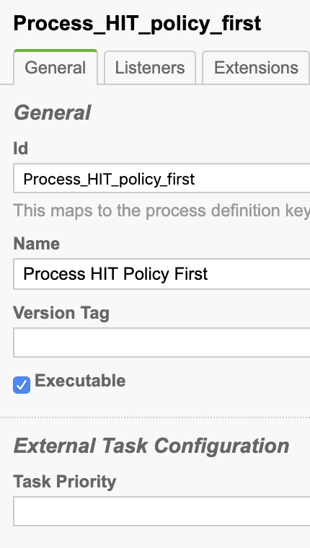

Id: Process_HIT_policy_first
Name: Process HIT Policy First

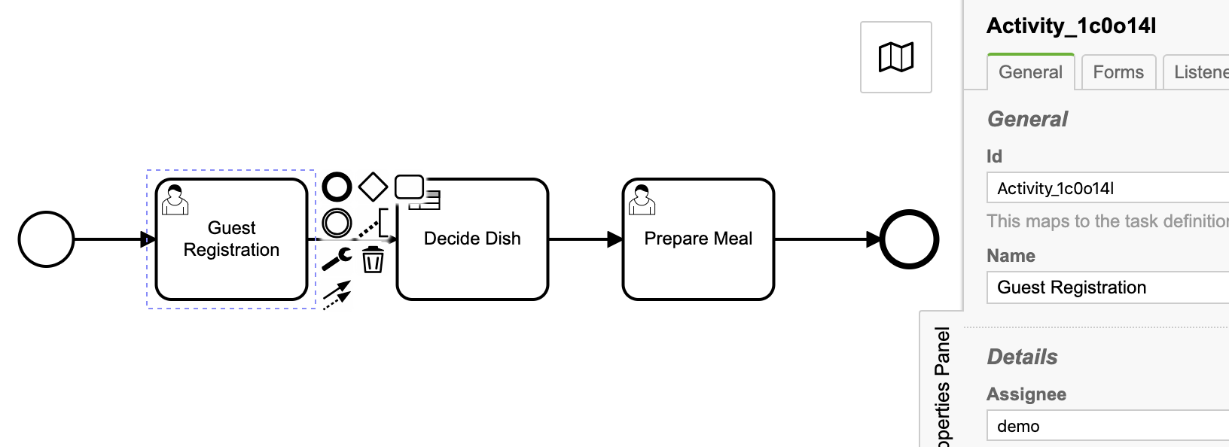
2. User task: Guest Registration
Id: Activity_1c0o14l
Name: Guest Registration
Assignee: demo

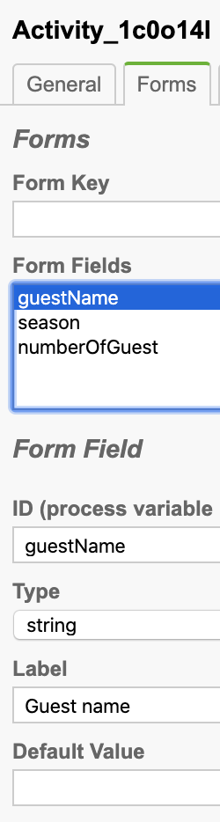
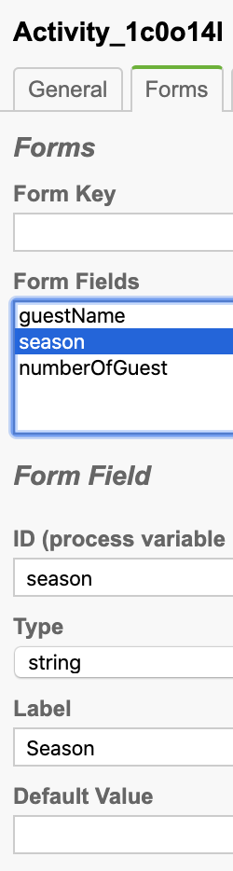
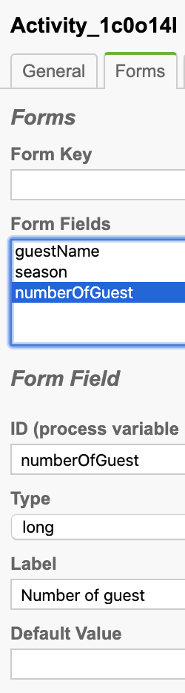
Task form:

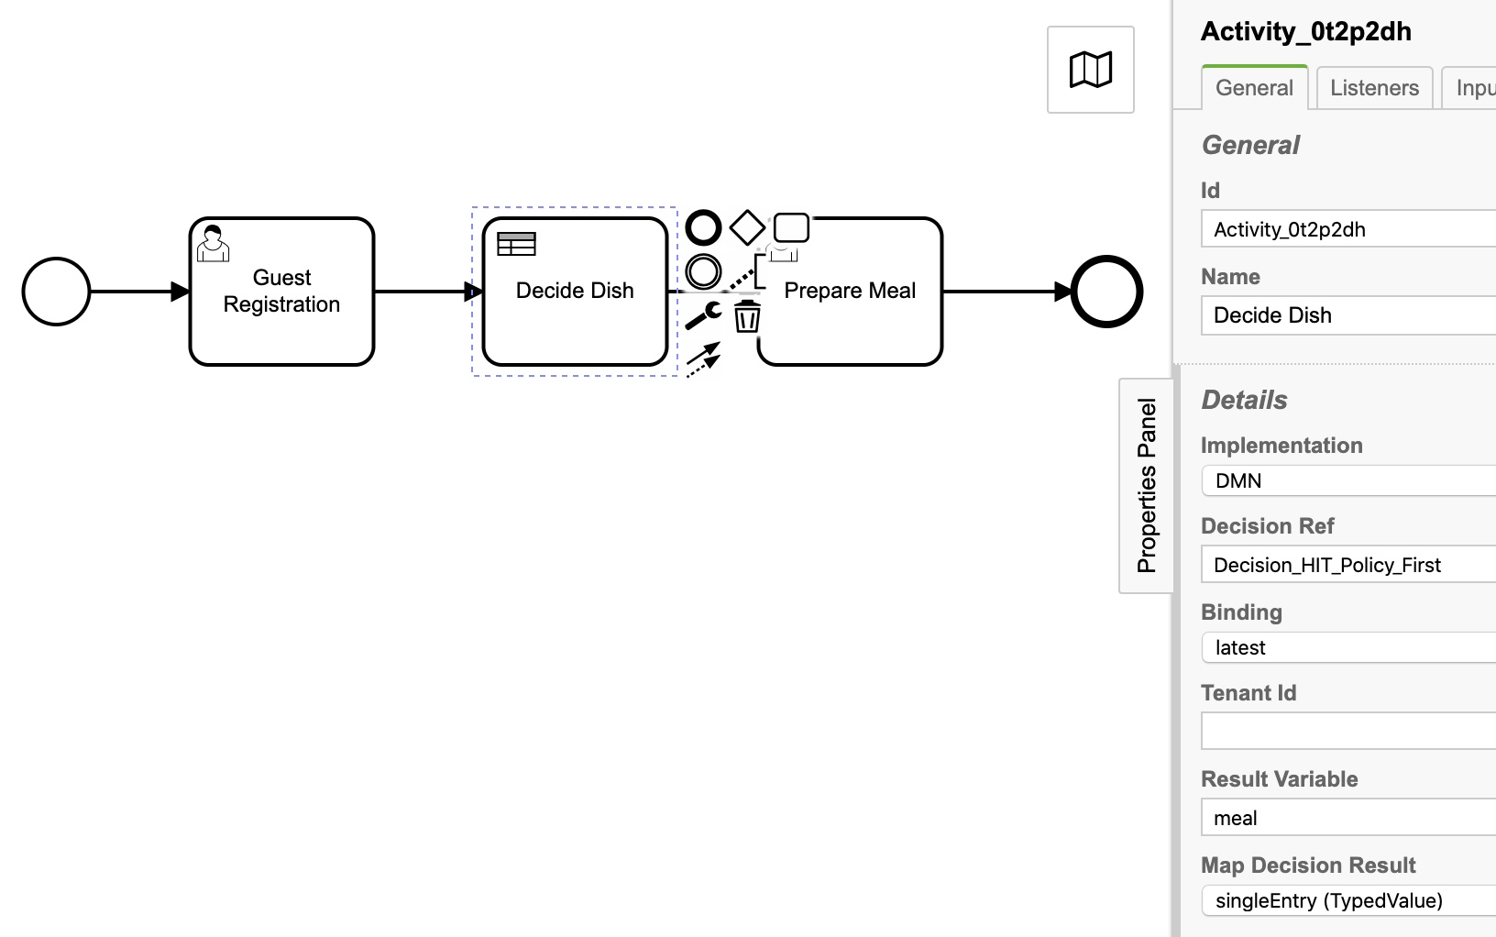
3. Business rule task: Decide Dish
Id: Activity_0t2p2dh
Name: Decide Dish
Implementation: DMN
Decision Ref: Decision_HIT_Policy_First
Binding: latest
Result Variables: meal
Map Decision Result: signleEntry(TypeValue)

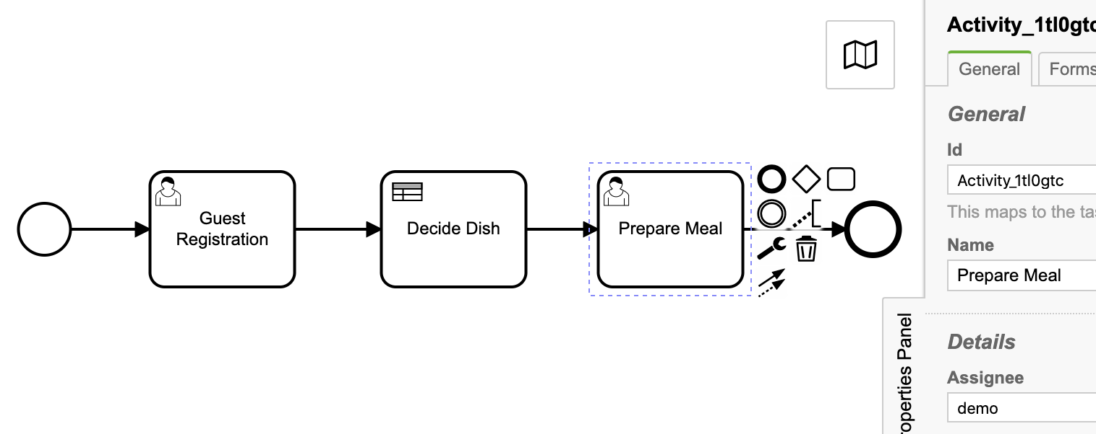
4. User task: Prepare Meal
Id: Activity_1tl0gtc
Name: Prepare Meal
Assignee: demo

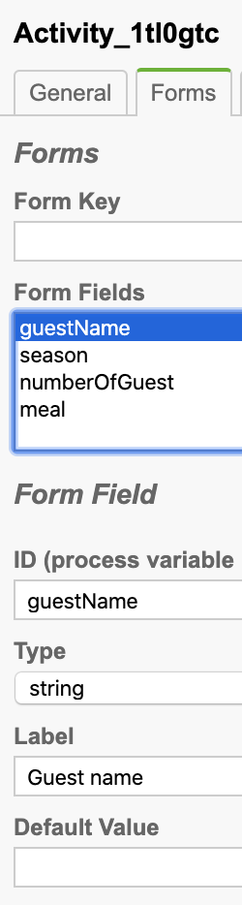
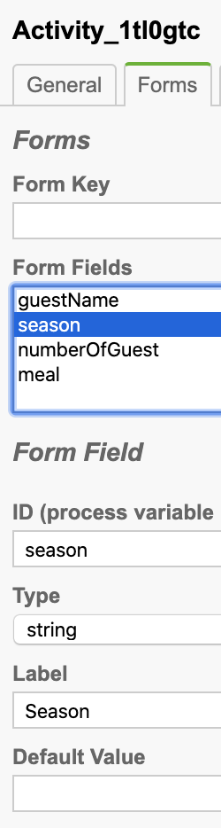
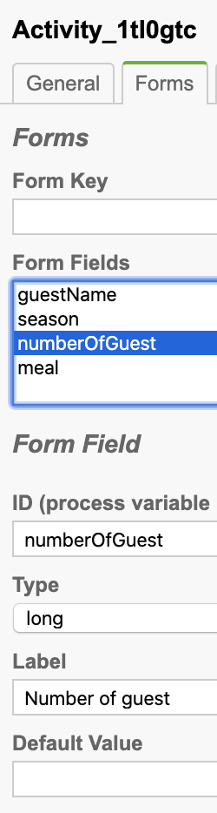
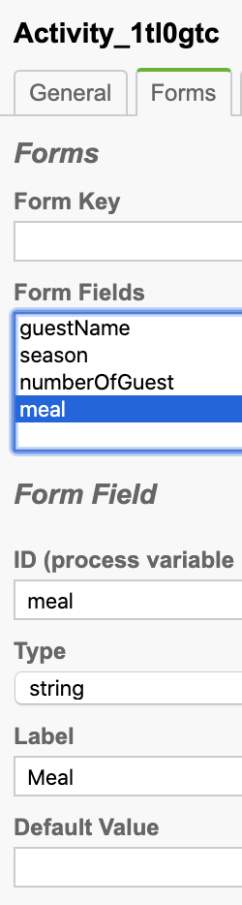
Task form:

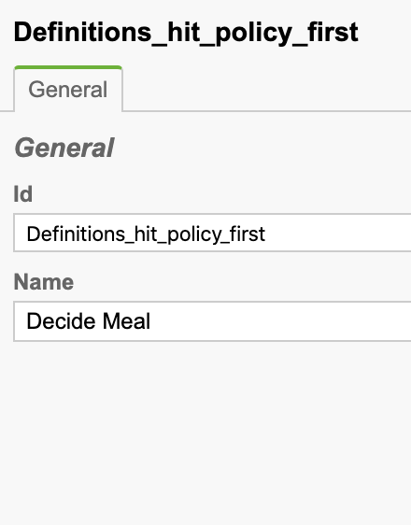
5. Now lets model decision table
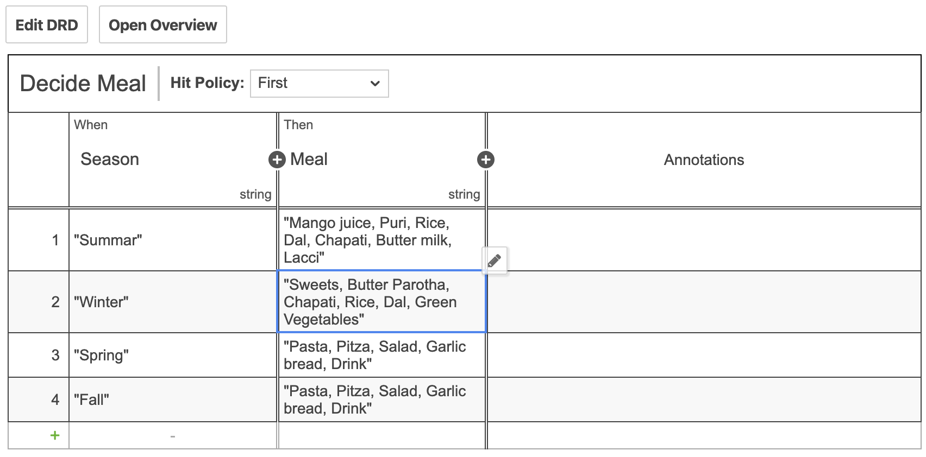

Id: Definitions_hit_policy_first
Name: Decide Meal

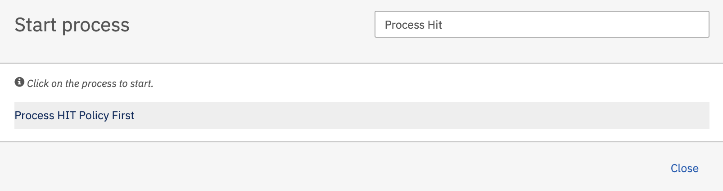
6. Deploy the process and decision table definition and start the process

Hit the Process HIT Policy First and hit the Start button to start the process.

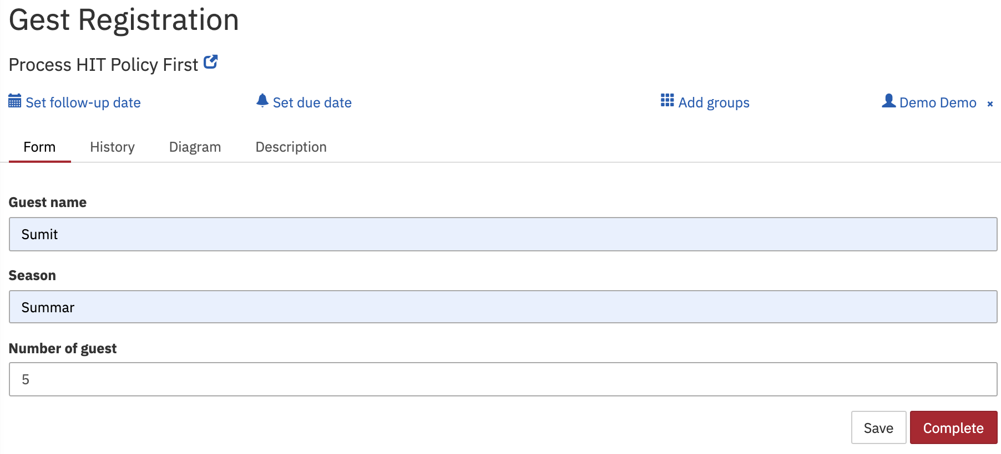
As per process definition, Guest Registration user task will get generated.

Full-up the form and press Complete button.

As per process definition, Business rule task will get executed with provided input Season = Summar and it will generate single output as meal = Mango juice, Puri, Rice, Dal, Chapati, Butter milk, Lacci and user task prepare meal will get generated as below.

